Architecture Document
1. Application
1.1 Introduction to the System
The Global SAP Career and Technical Advisor AI is an advanced, enterprise-grade chatbot system designed to provide real-time, highly accurate guidance to students regarding university programs, costs, and SAP configurations. The system processes complex, unstructured data (such as PDF tables and live Google Sheets), stores it as mathematical representations using multilingual embeddings, and retrieves precise answers. Built on an advanced Retrieval-Augmented Generation (RAG) architecture, it prevents AI hallucinations through strict "Critic" protocols and features a Semantic Router to optimize processing speed. Furthermore, the frontend is equipped with a real-time Web Speech API to provide an interactive, multilingual voice-to-text user interface.
1.2 Retrieval-Augmented Generation (RAG) Architecture (Selected Approach)
After evaluating standard Large Language Models (LLMs), a structured RAG Architecture combined with a Microservices API backend was selected. Standard LLMs are prone to hallucination and data staleness. The RAG architecture guarantees that the AI only answers based on verified, injected documents, citing its sources automatically. The system consists of the following modular workflows:
- Multimodal Ingestion: Processing PDFs/Images via LlamaParse Vision AI.
- Human-in-the-Loop Quarantine: A staging area where administrators approve parsed data before database injection.
- Live Admin Loop: Instant synchronization with external Google Sheets to override stale data without file uploads.
- Semantic Routing: A "Traffic Cop" logic that distinguishes casual greetings from heavy database queries to save computational resources.
- Vector Database Storage: Utilizing Qdrant for high-speed, multidimensional semantic search.
1.3 Traditional Fine-Tuning vs. RAG
Traditional LLM fine-tuning was evaluated but not chosen because updating factual data (like tuition costs) requires expensive and time-consuming model retraining. RAG was selected because it allows instant, zero-latency knowledge updates (Authority Level 0) via database synchronization without ever retraining the core model.

2. Use Case Diagram
The Use Case Diagram represents system interaction from the perspective of the users. Actors:
- Student (End User)
- Administrator
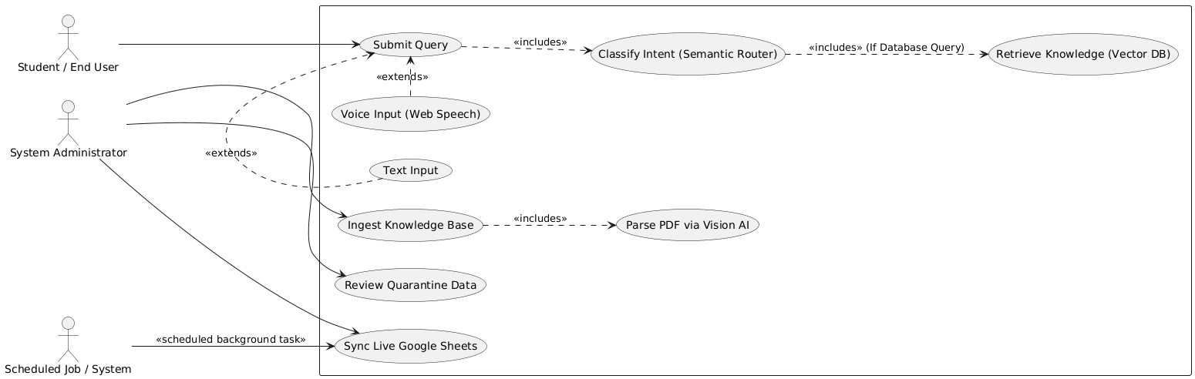

Explanation:
The Administrator focuses on data governance—uploading documents, approving quarantined text, and syncing live sheets. The Student interacts with the system conversationally, utilizing text or voice inputs to receive validated, cited answers.
3. Class Diagram
The Class Diagram describes the internal structure of the backend application and the relationship between major RAG components.
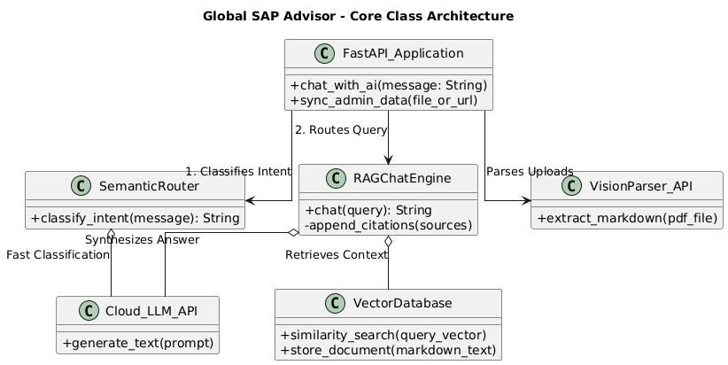

Explanation:
The WebUI communicates with the FastAPIBackend. The backend delegates tasks between the SemanticRouter (for intent classification) and the RAGChatEngine. The chat engine relies on QdrantVectorDB for retrieving semantic knowledge before synthesizing the final response.

4. Database
4.1 Conceptual ER Diagram
Unlike traditional SQL databases, this system uses a Vector Database. The ER Diagram represents the conceptual relationship between the uploaded data sources and the mathematical embeddings.
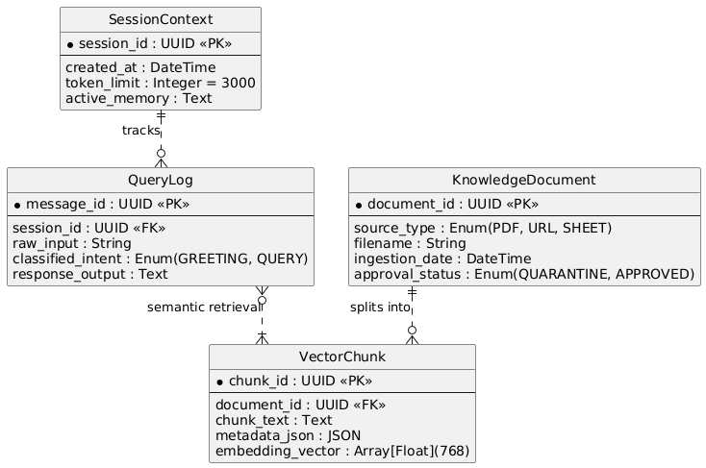
Explanation:
The ER Diagram shows how administrative KnowledgeSources (like PDFs or Sheets) are chunked into multiple VectorNodes. When a UserSession initiates a QueryMessage, the system retrieves the most relevant VectorNodes to construct the answer.
4.2 Conceptual Schema Design
KnowledgeSource(source_id, filename, origin_type, approval_status)
VectorNode(node_id, source_id, text_content, high_dimensional_embedding) UserSession(session_id, timestamp, active_memory_buffer)
QueryMessage(message_id, session_id, intent_type, content.

5. Data Flow Diagram
5.1 DFD Level 0
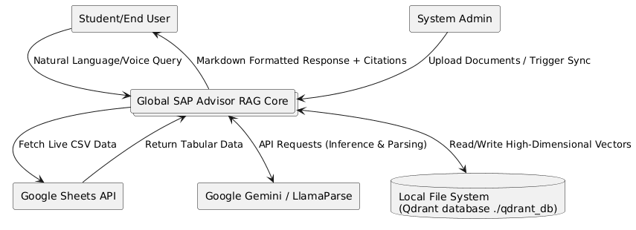
Explanation: This diagram shows the system as one overarching process interacting with external entities (Users, Admins) and the local/cloud Vector Database. It provides a high-level overview of system boundaries.

5.2 DFD Level 1
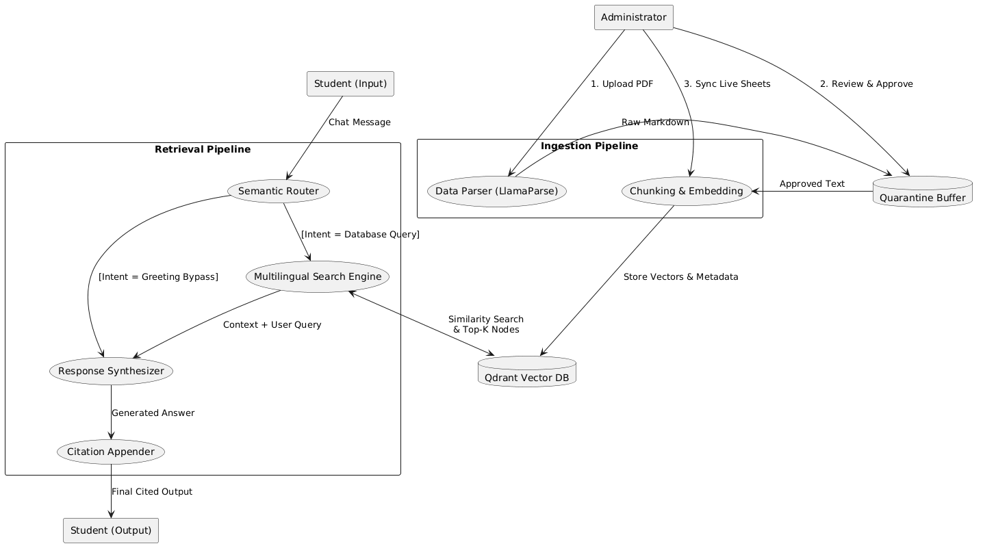
Explanation:
DFD Level 1 explains the step-by-step internal processing flow. It highlights the Semantic Router's pathing: bypassing the heavy database for simple greetings, or routing complex questions through the Multilingual Embedding engine, Vector DB, and Citation Appender.

6. Sequence Diagram
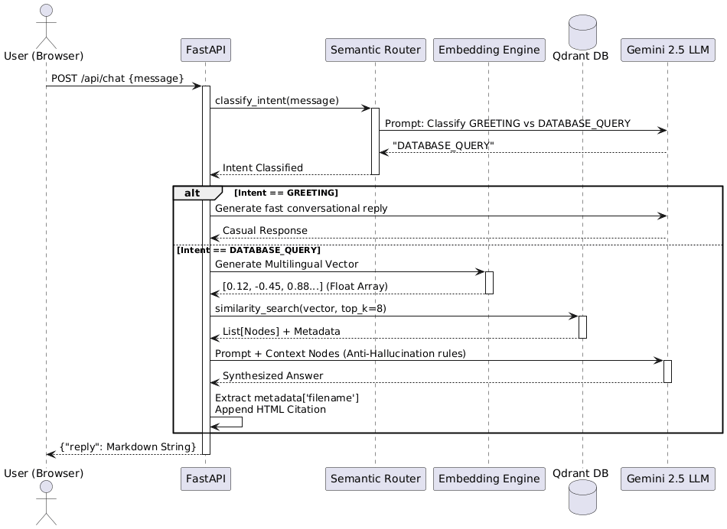
Explanation:
This diagram shows the chronological order of interactions during a complex database query. It illustrates the precise journey from the user's voice input to the API, through the router and Qdrant database, ending with the Gemini LLM appending faded citations to the UI.

7. Deployment Diagram
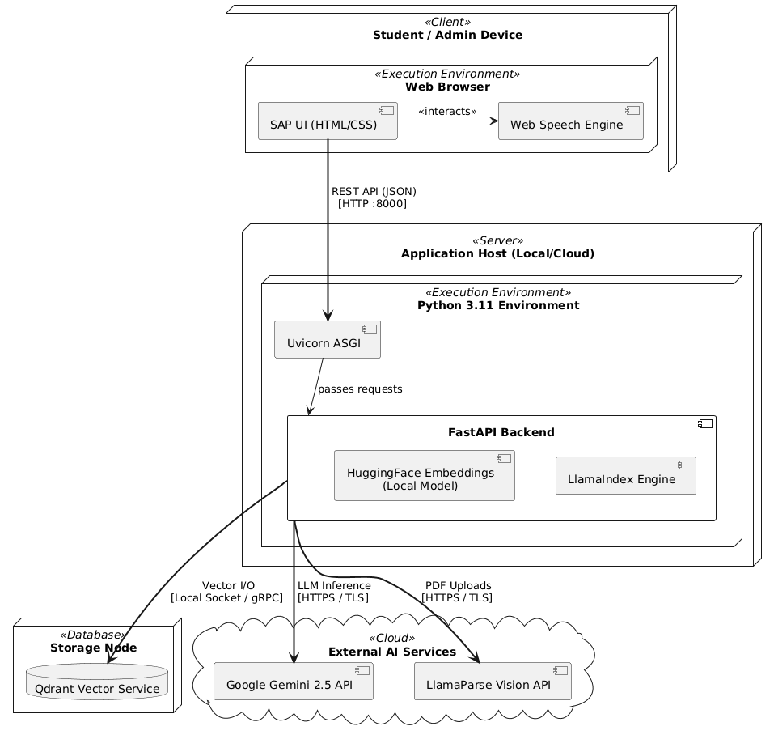
Explanation:
The Deployment Diagram illustrates the physical distribution of system components. The browser handles the UI and microphone API, communicating via REST to the Cloud Application Server (FastAPI). The server acts as a bridge, querying external AI APIs (Gemini, LlamaParse) and the Vector Database Server.

Conclusion
The selected RAG Architecture provides a highly scalable, hallucination-resistant solution for the Global SAP Advisor. The integration of a Semantic Router ensures cost-effective speed, while the Multilingual Embeddings natively break down language barriers. The Admin Loop and Quarantine Zone guarantee absolute data integrity, making the architecture robust enough for both academic demonstration and full-scale industrial deployment.

